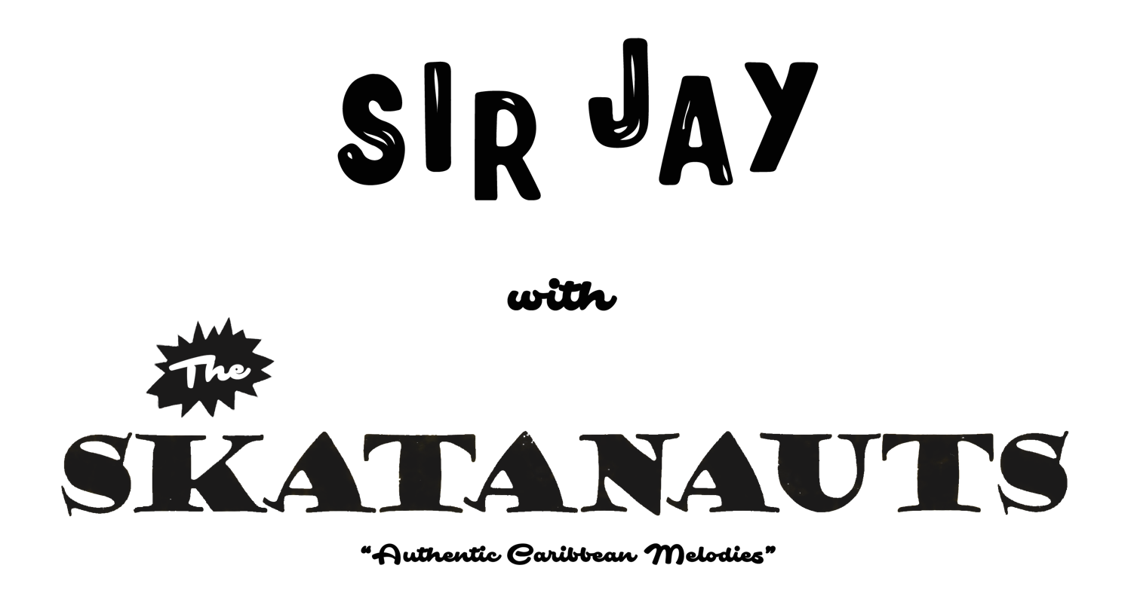

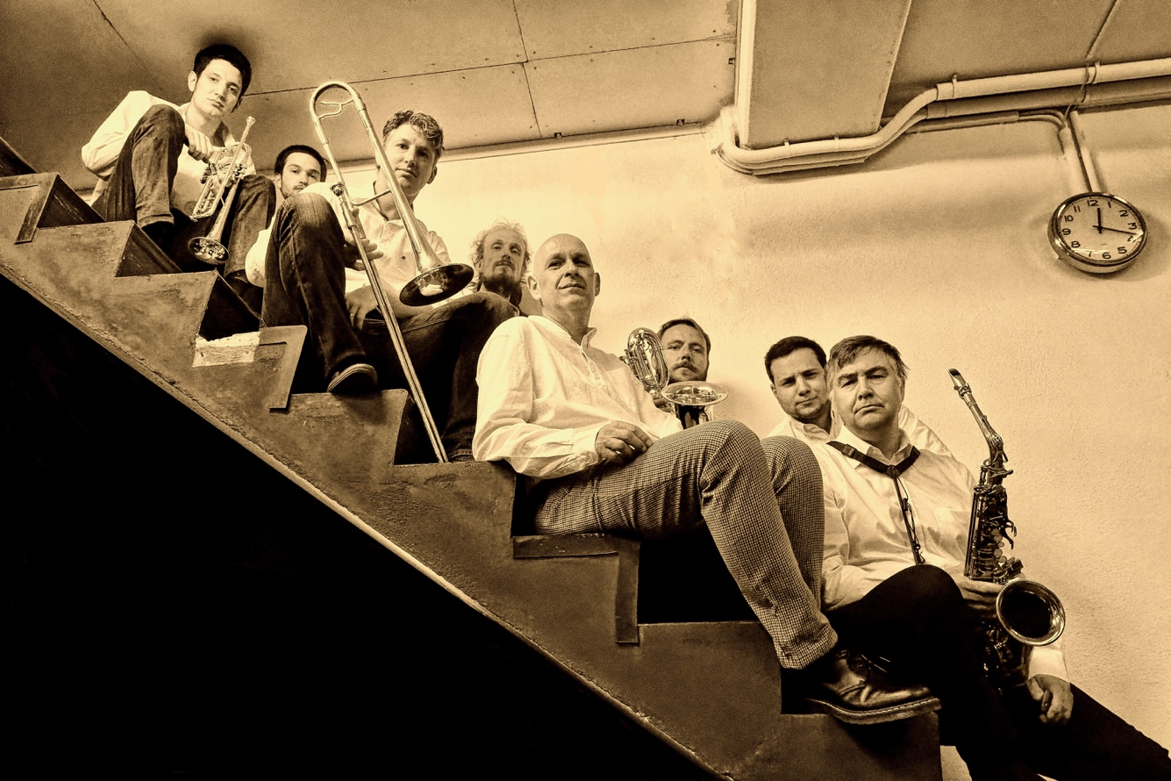

ABOUT

Are you ready for a musical trip to 1960s Jamaica? Get ready, get set, because Sir Jay & The Skatanauts will take you there! The 9-piece outfit from Switzerland and their highly addictive and irresistibly danceable Latin, Jazz and Rhythm & Blues infused Offbeat draw inspiration directly from the founders of Ska music with the likes of Don Drummond and Tommy McCook & the Skatalites. Led by Sir Jay, a self-proclaimed Ska Nutter and veteran on the Ska scene, the Skatanauts are devoted to the authentic beat that conquered the world in 1964. Performing exclusively original compositions, their raw and honest approach to entertainment - which can be heard in every tone - strikes a nerve with young AND old. Their mission is quite simple: to make you move and groove - for days and extra days!

MUSICIANS

Andreas Haase (tb) // David Hutter (bs) // Helmut Gruber (ts) // Jay Schaetz (p, vox) // Kaspar Hensel (tp) // Max Kueste (dr) // Michael Heisch (b) // Per Antonsen (as) // Raphael Tschuemperlin (tp)

BOOKING

Contact: info@skatanauts.com
Manager: Jay Schaetz

